Modes Theory™ Client Assessment Partner Training
V2.0 updated 11/3/23. Questions, comments, or feedback? Email Modes@ConnectWise.com.

Table of Contents
- Assessment Overview
- Goals (Why)
- Prerequisites to Understanding the Assessment
- Prerequisites to Delivering the Assessment
- Preparation for Training
- Format
- Reminders (Modes Theory and Operational Maturity Levels)

- Assessment Questions (What)
- Assessment Recommendations
- Audience (Who)
- Timing (When)
- Location (Where)
- Methodology (How)

- Additional Opportunities

- Next Steps

- Reminders

- Appendix
- Appendix A: Modes Assessment Questions
- Demographics
- Destination
- Mode Selection
- 8 Modes Characteristics
- Appendix B: Operational Maturity Level Questions
- 9 OML Traits
- Appendix C: Additional Questions
- Client’s alignment with their leadership team.
- Client’s request to discuss other topics which might impact their business.
- Appendix D: Digital Intelligence & Growth Implementation Plan (Digi-Plan)

- Assessment Overview

- Goals
The Modes Theory™ Client Assessment (“the assessment”) is designed to improve alignment between prospective and/or current clients (or “SMBs”) and Technology Service Provider (TSPs or “partners”). Additionally, the assessment may clarify future growth mindsets, deepen relationships, and differentiate the TSP in the marketplace. Ultimately the assessment delivers these win-win-win end-in-mind objectives:
- SMBs transform as part of a thriving IT ecosystem.
- IT solution providers achieve their most ambitious vision of success.
- ConnectWise drives partner and SMB success through alignment.

- Prerequisites to Understanding the Assessment
TSPs should complete these activities prior to engaging with a prospect or client:

- Complete the Modes Owner Assessment. If the TSP operates with a leadership team, they should complete the Modes Leadership Team Assessment.
- Achieve consensus and align on the Mode of the TSP’s company based on direction from the owners.
- Understand fundamentals of Modes Theory and Operational Maturity Levels™ based on reading the assessment report. Pursue additional learning as outlined in the Appendix.
- Prerequisites to Delivering the Assessment
- Complete the Modes Client Assessment.
- Watch the Modes Client Assessment Overview Video.
- Role play completing the assessment and engaging in client conversations internally before engaging with a client.
- Agree that the assessment is suitable for use with a targeted subset of initial clients. (Estimate: 3-5 clients) Choose one client to have in mind during your role play.

- Assessment Format

The Modes Client Assessment consists of two parts: 1) the online questionnaire (“the questions”), and 2) the PDF report (“the report”). For simplicity, we will refer to the combination of questions and report as the assessment.

The Modes Client Assessment is very similar to the Modes Owner and Modes Leadership Team Assessments. Primary differences include:
- Removal of the open-ended “How will you get there” and “What is your timeline” questions.
- Replacement of OML questions targeting TSPs with questions targeting SMB clients.
- Addition of an open-ended question asking the client to name topics to discuss with the TSP.
- Removal of opt-in questions related to ConnectWise.
- Reduction in the length of the PDF report to simplify communication between TSP and SMB.

- Reminders (Modes Theory and Operational Maturity Levels)
All team members who engage clients in the Modes Client Assessments need to be educated and confident about how to use the tool, Modes Theory, and Operational Maturity Levels. Often the owner(s) may complete the Modes Owner Assessment, then expect other team members (Sales Executive, VCIO, etc.) to conduct the Modes Client Assessment with little or no understanding of Modes Theory and/or OML. This is a recipe for failure.
All questions, responses, and additional resources are available in the Appendix. Remember, Modes and Operational Maturity work in combination to answer these three questions.
- What is your destination? What are you trying to build?
- How will you get there? What does your journey look like? (OML™)
- When is your timeline? How long do you have?
The TSPs’ owner(s) assess their relationship with growth to determine which of four Modes Mindsets best describes their thinking and behavior today. Their Modes Mindset is influenced by the realities of the Modes Mindset of their leadership team and the OML of the business.
The characteristics that impact how TSPs view growth (purpose, work, life, risk, profitability, culture, sales, other) are also characteristics which impact their SMB clients. This parallel is the foundation of why the Modes Client Assessments also applies to clients.

- Assessment Questions (What)
Every question and potential response in the assessment is included in the Appendix. You must understand how to apply these questions effectively when engaging with a client.

Guidance
Here is general guidance for engaging with clients when completing the assessment:
- Make sure you align the right individual(s) on your team with the right individual(s) at the client. You may complete the assessment with one or more people to increase alignment and buy-in. Understand additional people introduce additional complexity (and time) into the assessment process.
- Move through the questions without excessive tangential conversation; it’s not a time for selling. You can discuss findings, needs, wants, gaps, pain points, products, and services when you review the PDF report.

- You must be familiar with the questions and response options for the assessment to produce value. You need to practice explaining the Modes and Traits, how they relate to your business, and why the client should care.

- You need to help the client own their responses; the responses are theirs and not yours. You may experience a wide range prior understanding from new prospects to long-time clients. Regardless of your understanding, do your best to explain the response options. Use the client’s questions about the responses to identify areas in need of clarity, education, and/or follow-up.

- You may benefit from using the following communication strategies and phrases when completing the questions and reviewing the PDF report:
- “Help me understand why you answered that way.”
- “I’m curious about…”
- “What I hear you saying is…”
- “Tell me more about…”
- “Interesting. That hasn’t been my experience working with your company (or with similar companies).”
- “I’m wondering about…”
- “Walk me through why (or how) you answered this way.”
- “I respect your answer, though I want to be sure we come back to it later.”
- “I’m working from these assumptions – what about you?”
- “Let’s step back and make sure I’ve clearly explained what we’re trying to answer here.”
(Adapted from Dare to Lead, by Brené Brown)
Although the questions and responses are available in the PDF report, the only time you will see the Modes and Trait questions followed by all response options together is online and in this training documentation.
- Assessment Recommendations

- Audience (Who)

The partner typically engages with the assessment through an owner, VCIO, or Sales Executive. The partners’ point of contact is typically positioned as a business consultant and trusted relationship owner given the unique nature and potential sensitivity of the questions. Additionally, the point of contact needs to establish a high degree of trust since the assessment may lead to opportunities for aligning with various client needs.

The client typically engages with the assessment through an owner or C-level decision maker. The client’s point of contact is a trusted relationship owner given the unique nature and potential sensitivity of the questions. Additionally, the point of contact needs to establish a high degree of trust since the assessment may lead to opportunities for aligning with offerings from the TSP.

- Timing (When)

The TSP should be prepared to complete the assessment with clients after completing the Prerequisites to Understanding the Assessment and Prerequisites to Delivering the Assessment. These prerequisites include completing the assessment, role-playing the TSP-to-client conversation, and identifying a small group of target clients.

Additionally, TSPs should consider aligning the assessment with the ongoing rhythm of current prospect and/or client meetings. TSPs should incorporate the assessment into current processes to avoid fatiguing clients. Reassessments may take place annually, or when owners and/or leaders change.

- Location (Where)
Access to Modes Resources
Modes Client Assessment
Modes Theory webpage with other assessments (Owner and Leadership Team).
Modes Leadership Team Alignment Activity Discussion Worksheet (on Evolve Hub)
Videos of Partners describing their Modes Mindset (scroll down)
Modes Team Member Discussion Worksheets (in development)

As shown in the Methodology section below, TSPs have four main options to complete the assessment. Options vary based on where the parties are located, and the device used.

- Methodology (How)
In general, follow these steps to complete the assessment:
- Identify who from the client will complete the assessment, and why.
- Identify who from the TSP will guide the client through the assessment, and why.
- Determine the best option for completing the assessment.
- Complete the assessment and download the results.
- Review the results to identify potential findings.
- Determine next steps and commit to action items.
- Record the results in TSPs’ CRM system for use in future relationship-building.
There are four options for completing and reviewing the assessment. As shown below (and numbered in order of preference) the option for the TSP and client to meet in the same office and use the TSPs’ technology device is preferred (See #1). The partner knows the URL, serves as the guide, downloads the report, and plans next steps.
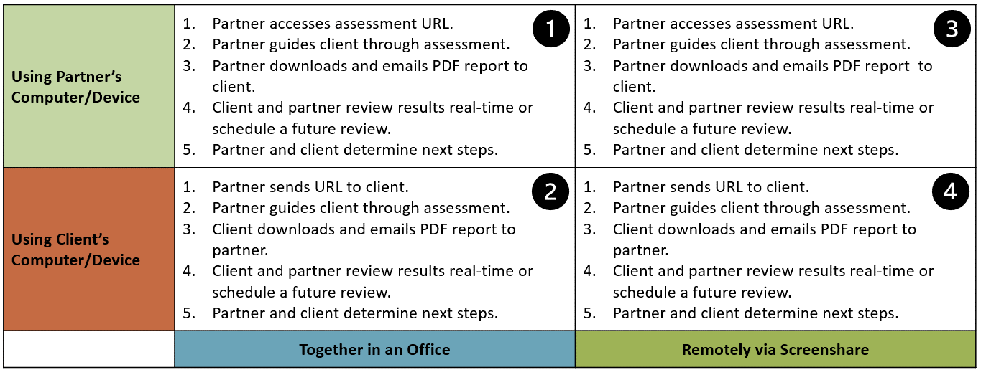
Bottom Line: Do not ask the client to complete the assessment without you present as the guide.

- Additional Opportunities
TSPs continue to learn as the number of prospects and/or clients they assess grows. TSPs gain insights into clients’ Modes and OML, perspectives on growth, additional solutions, and how to align with their clients. TSPs can now pursue additional opportunities such as:
- Conduct targeted marketing campaigns (email, L&L, offerings).
- Improve alignment with prospective clients (new logos).
- Deepen understanding during the onboarding process (strategic fit).
- Develop a common language and multi-dimensional client profile:
  - A, B, C (engagement, relationship, profitability, other)
  - Mode
  - OML
- Conduct reassessments as part of a Strategic Technology Review rhythm.
- Educate new team members (sales, marketing, technical).

- Next Steps
- (See Step 4 above) Client and partner review the PDF report results real-time or schedule a future review.
- Review the report summary to identify self-selected Mode, distribution of Mode Characteristics (1-8), and OML.
- Review the assessment questions and responses for reinforcement.
- Review the Other questions, especially the technologies which may impact the clients’ business.

- (See Step 5 above) Partner and client determine next steps.
- Work with the client to create a comprehensive list of clarifying questions, follow-up topics, and action items. The length of the list is less important than ensuring nothing was missed. Prioritize the top 2-3 activities to demonstrate successful execution and results.
- Work with your team and to understand how the top 2-3 activities fit within existing work in process.
- Consider the “Digital Intelligence & Growth Implementation Plan (Digi-Plan)” in Appendix D. The outcome of a Digi-Plan review may produce opportunities for 1) transforming the clients’ business in alignment with the TSPs’ offerings, and 2) better aligning both parties with respect to their Modes Mindsets.
- Communicate with the client regarding your plans and move forward.

- Create a list of “what we could do better next time” lessons learned for improving the next assessment. Apply these yourself or share these with others on your team who will conduct future assessments.
- Reminders
- The assessment utilizes a 3rd party platform licensed to ConnectWise. Given the current structure, partners do not have a login to their instance of the platform.
- Partners cannot change or re-brand the assessment questions or PDF report.
- Each assessment is completed individually (no updating or partner reporting).
- Each assessment should be completed and downloaded in one sitting.
- ConnectWise does have access to the assessments and counts to monitor usage.
- Assessments consist of questionnaires and PDF reports. All assessments in the Modes Theory system will receive periodic version updates.
- Success depends on a working knowledge of Modes Theory and Operational Maturity Level. Complete the Modes Client Assessment and review the PDF report to plan engagements.
- Feedback is encouraged. Send feedback and comments to Modes@ConnectWise.com.
- Review and share the training in this document.

- Appendix
Appendix A: Modes Assessment Questions

Demographics
The assessment begins by asking questions about the client’s business and the individual at the TSP who requested the client complete the assessment. This information will appear on the assessment report.
The initial demographic questions enable the TSP to confirm the contract information and role of the SMB contact. The drop-down for “role” offers options including Owner/Shareholder, Leadership Team Member, Vendor, Other, and N/A-Prefer Not to Answer.
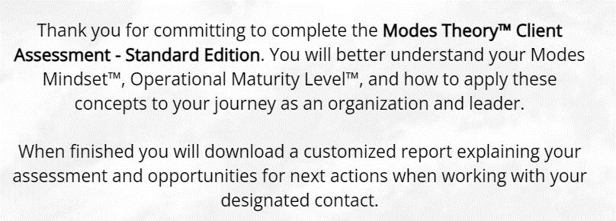
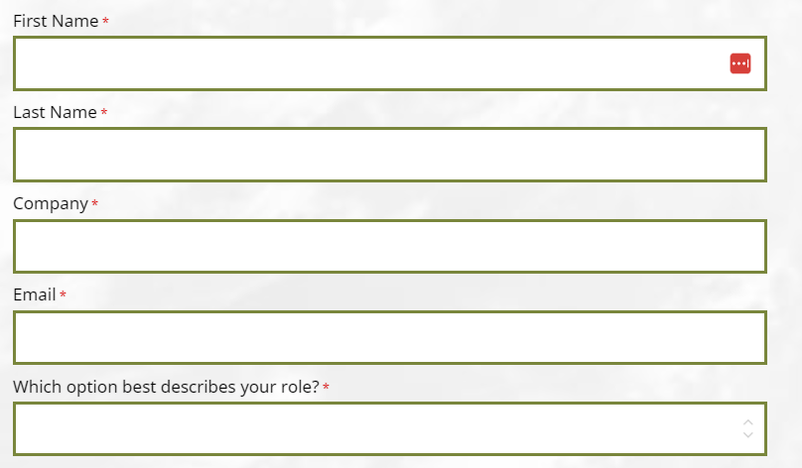
The client is asked to share the number of owners and leadership team members. The client may choose not to share, but knowing this information provides insights into the size and scope of the decision-making team.
Options for the “# of Owners” field include: 1, 2, 3, 4 or more, Do not know, and N/A-Prefer Not to Answer. Options for the “# of Leadership Team Members (exclude Owners)” field include: 0, 1, 2, 3, 4, 5, 6 or more, Do not know, N/A-Prefer Not to Answer
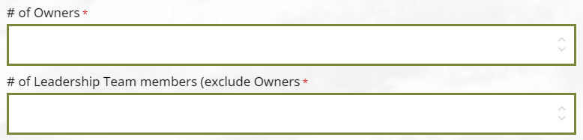
Next is where the TSP enters their contact information which also appears on the PDF report. Options for “Client’s Industry” include Banking/Financial, Construction, Healthcare, Information & Media, Legal, Manufacturing, Other Professional Services, Other Services, Retail, and Wholesale.
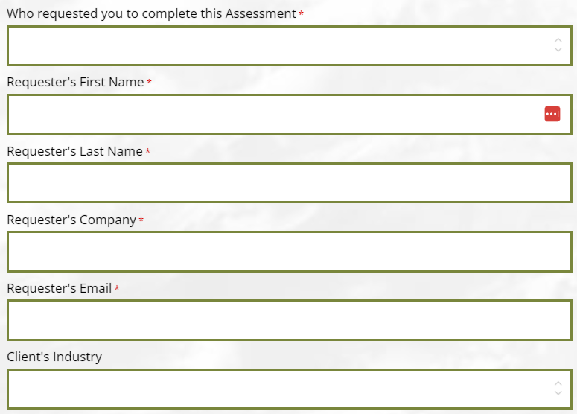
Destination
“What is your destination?” is one of the three foundational questions in Modes Theory. The other two (“How will you get there” and “When is your timeline”) have been removed to simplify the conversation with the. You are welcome to address these questions on your own based on your relationship with the prospect or client.
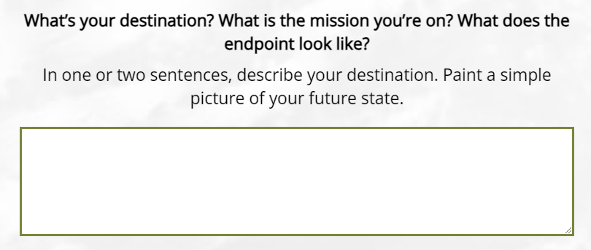
Discussion Value: Knowing the prospect’s or client’s destination provide perspective on their “end in mind.” Ask clarifying questions about the destination and the path the client is on.
Mode Selection
Helping the client understand and select their current Mode is critical to the success of the assessment process. Unlike other assessments, in the Modes assessment the client self-selects their Mode, then answers questions which may or may not validate their selection. Additionally, you the TSP guides the client through the self-selection and interpretation of validation answers.
Understanding the Mode Mindset of your organization and Modes in general will be helpful in discussing the client’s Mode.
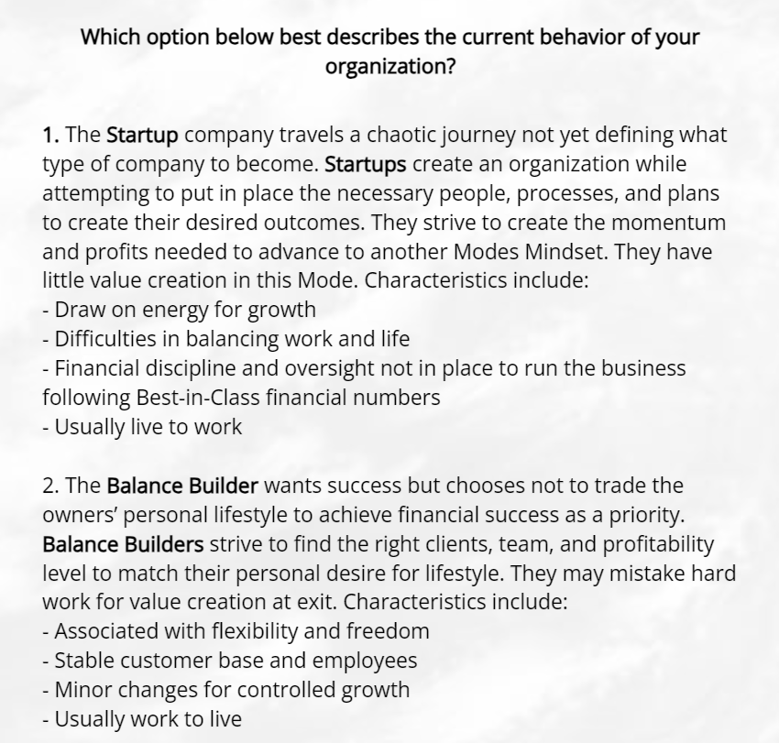
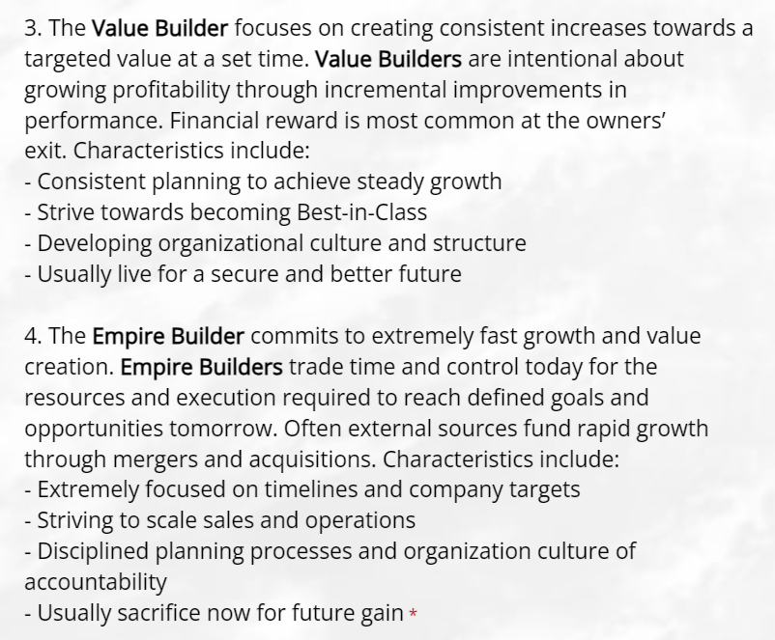
Discussion Value: This question is key to determining how the client thinks about their relationship with growth. Avoid guiding the client towards (or away from) one “right” answer. You are better off letting the client choose a Mode Mindset, then validate the Modes Mindset using the 8 Modes Characteristics below.
8 Modes Characteristics
After self-selecting a Modes Mindset, the assessment asks the client to assess their thinking and behavior across eight Modes Characteristics. The assessment is built to document responses for each of the four Modes Mindsets for each of the eight Characteristics.
The Modes Mindset responses are consistently ordered so A = Startup, B = Balance Builder, C = Value Builder, and D = Empire Builder. (This methodology parallels that used by OML except for a 1-5 scale.)
- Characteristic 1 – Purpose of the business
- Characteristic 2 – Focus on work and life
- Characteristic 3 – Reason for worry and risk
- Characteristic 4 – Source of financing
- Characteristic 5 – Status of profitability
- Characteristic 6 – Accountability in culture
- Characteristic 7 – Sales approach
- Characteristic 8 – Perspective on growth

- Characteristic 1 – Purpose of the business

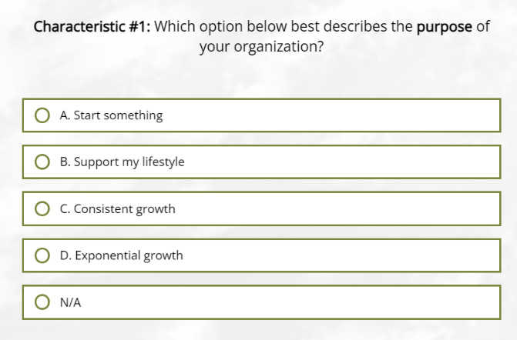
Discussion Value: Characteristic 1 provides perspective on the purpose of the client’s business to understand long-term alignment and motivation. Each response offers the opportunity to ask, “Tell me more about what you mean” and/or “Has your purpose changed from the past or do you see it changing going forward.”

- Characteristic 2 – Focus on work and life.

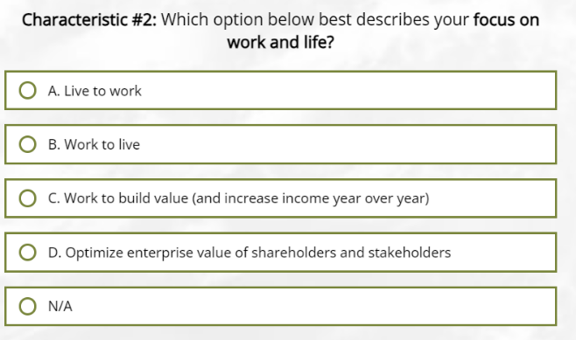
Discussion Value: Characteristic 2 gives you insights into the client’s perspective on work and life. Each response offers the opportunity to ask, “Tell me more about what you mean” and/or “Has your focus changed from the past or do you see it changing going forward.”

If you feel comfortable, this question is an opportunity to ask variations of “How long do you plan to work” and/or “When will you get there” related to building value in the business.

- Characteristic 3 – Reason for worry and risk

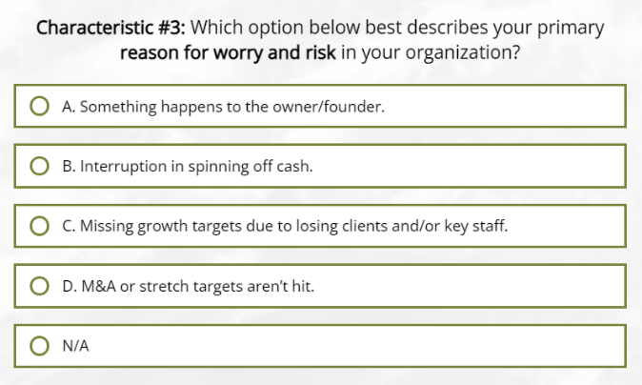
Discussion Value: Characteristic 3 gives you insights into the client’s reason to worry. The value of the question depends on who answers the question. Owners and non-owners may be reluctant to answer. If so, consider a more open-ended, “What is your biggest reason for worry or risk to the business” or What keeps you up at night.” Each response offers the opportunity to ask, “Tell me more about what you mean” and/or “Has your reason for worry changed from the past or do you see it changing going forward.”

- Characteristic 4 – Source of financing

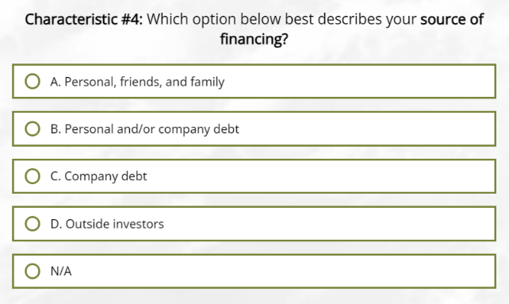

Discussion Value: Characteristic 4 gives you insights into the client’s financing. The value of the question depends on who answers it and their willingness to share. As the TSP owner, you may benefit from sharing similar financing sources or situations with the client owner. Owners and non-owners may be reluctant to answer so you may choose to skip the question.

- Characteristic 5 – Status of profitability

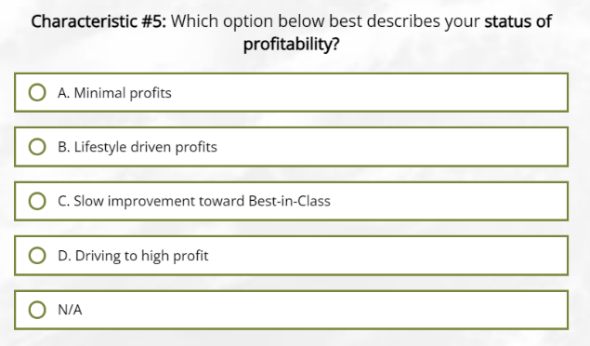

Discussion Value: Characteristic 5 gives you insights into the client’s path to profitability. The value of the question depends on who answers the question. Owners and non-owners may be reluctant to answer. If so, consider a revenue-focused question like, “On average, what increase in revenue did you experience over the past 5 years” and “What increase in revenue do you expect over the next 5 years.” (Estimate: 0%-10% Balance Builder; 10-20% Value Builder; Over 20% Empire Builder)

Each response offers the opportunity to ask, “What areas of your business have contributed most to profitability” and/or “What one thing related to technology would most improve your profitability” and/or “How do you set goals or benchmark your profitability.”

- Characteristic 6 – Accountability in culture

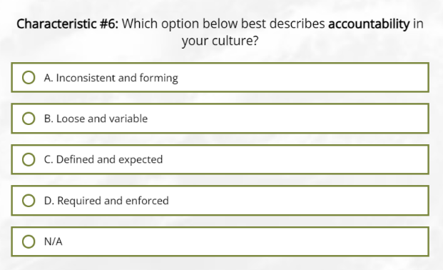

Discussion Value: Characteristic 6 gives you insights into the client’s culture and accountability. The value of the question reflects on how the client may enact recommendations and changes leading to a higher Operational Maturity Levels. You may already have experience working with the client and experiencing their culture.

Typically, this is a straightforward question for the client since the responses are relatively subjective. Each response offers the opportunity to ask, “Tell me more about what you mean.”

- Characteristic 7 – Sales approach

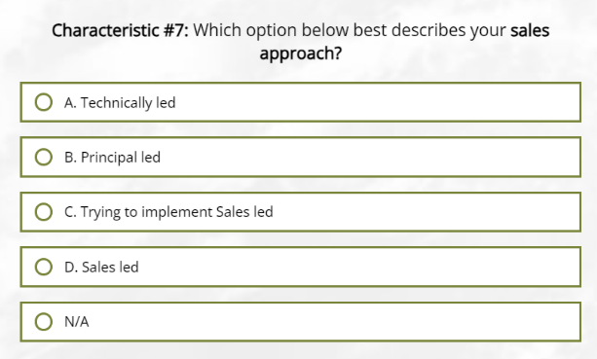

Discussion Value: Characteristic 7 gives you insights into the client’s approach to sales – a characteristic shared by every TSP owner and non-owner. The value of the question is to understand how the client structures their business to generate revenue. You may identify a need to enhance marketing or CRM systems, optimize vertical or line of business software, or address blockers.

Each response offers the opportunity to ask, “Tell me more about what you mean” and/or “Has your sales model remained consistent or changed over time.” You may add a more open-ended, “What is your biggest challenge with this sales model” or “What about your sales approach keeps you up at night.”

- Characteristic 8 – Perspective on growth

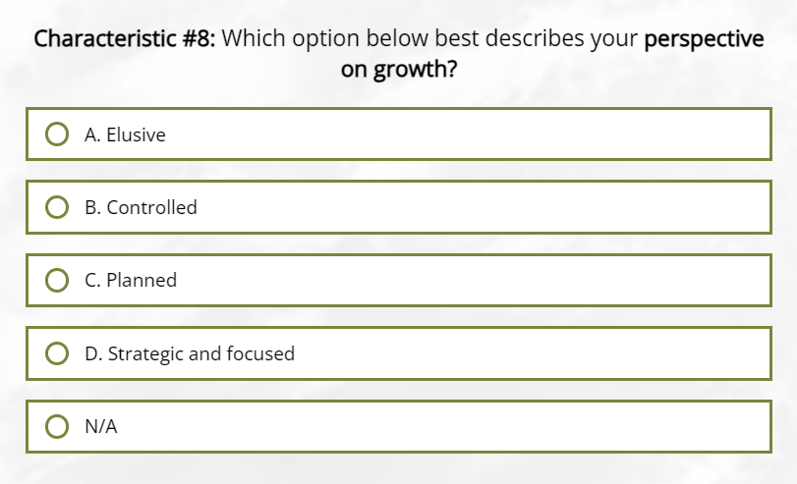
Discussion Value: Characteristic 8 gives you insights into the client’s perspective on growth – the key “relationship with growth” addressed in the previous selection of Mode Mindset. The value of the question is to confirm alignment. Each response offers the opportunity to ask, “Tell me more about what you mean” and/or “Has your focus changed from the past or do you see it changing going forward.”
Perspective on Future Mode
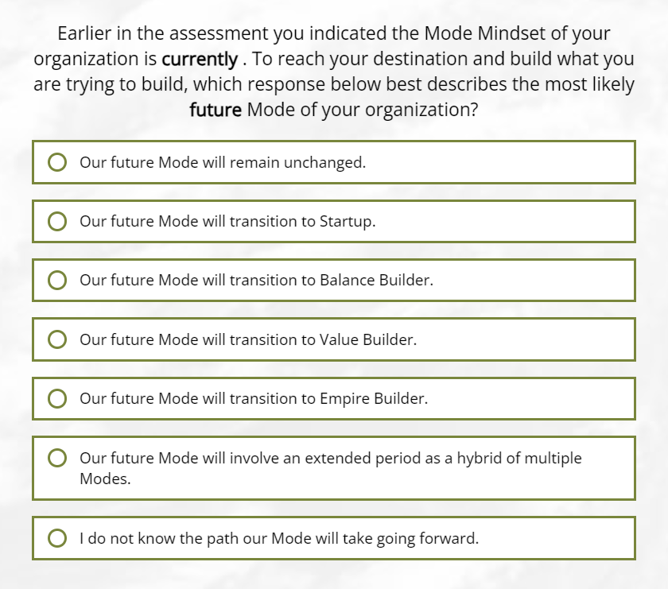
Discussion Value: The Perspective on Future Mode offers insights into potential changes in the client’s future Modes Mindset. The value of the question is to look ahead (and around corners) to anticipate change and confirm alignment. There is no wrong answer. The responses fall into four categories: 1) remain unchanged, 2) transition to another Mode, 3) exist as a hybrid of multiple Modes, or 4) status unknown.
Each response offers the opportunity to ask, “Tell me why you answered as you did.” For responses involving a transition, you may ask “Help me understand why you believe a transition to the <insert name> Mode will occur.”

Perspective on Personal Mode
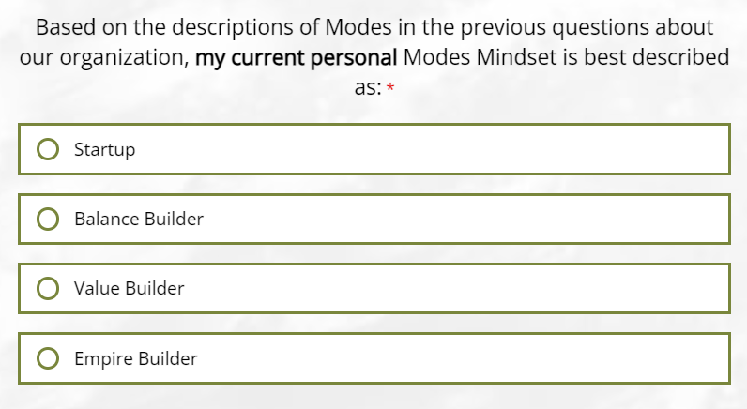
Discussion Value: The Perspective on Personal Mode offers potential insights into the client’s personal Modes Mindset. The value of the question is to compare the Mode of the individual with the Mode of the company at the current time.
Note: There is no wrong answer. You should be careful not to over or under value the client’s response. That said, this question offers yet another opportunity to validate the adoption and alignment of Modes Mindset. In cases where there is a single owner and you are conducting the assessment with the owner, the current Personal Mode and company Mode should be the same. When you are assessing with a second owner or non-owner(s), the Personal Mode may be different.
Each response offers the opportunity to ask, “Tell me why you answered as you did” and/or “Has your Mode changed from the past or do you see it changing going forward.”

Appendix B: Operational Maturity Level Questions
9 Operational Maturity Level Traits

The Modes Client Assessment to includes 9 questions designed to identify the client’s Operational Maturity Level™ (OML™). The questions focus on 9 Traits of IT management for SMBs.

These 9 Traits are divided into the 3 categories: 1) Operational Scalability, 2) Governance and Controls, and 3) Strategic Alignment and Business Value. Each Trait question includes one or more questions about the SMB client’s environment, then offers 3 scenarios of potential responses. The responses represent “Basic”, “Mid”, and “High” Operational Maturity Levels.

The numerical scaling of the 3 responses aligns with the traditional OML scoring levels of 1-5. In other words, the client will score an OML from 1-5, not 1-3. You need to be knowledgeable about how to explain the scoring to the client.

Note: You should role play your response to each of the 3 possible responses to the 9 Trait questions before engaging with clients. Remember you are not attempting to “solve” the clients’ issues during the assessment. Still, you need to be able to guide the client through the question and responses. To help the client, it may be useful to provide context or examples of how the questions and responses fit with the clients’ actual environment.

OML Category 1: Operational Scalability
Trait 1: Achieve productivity and efficiency.
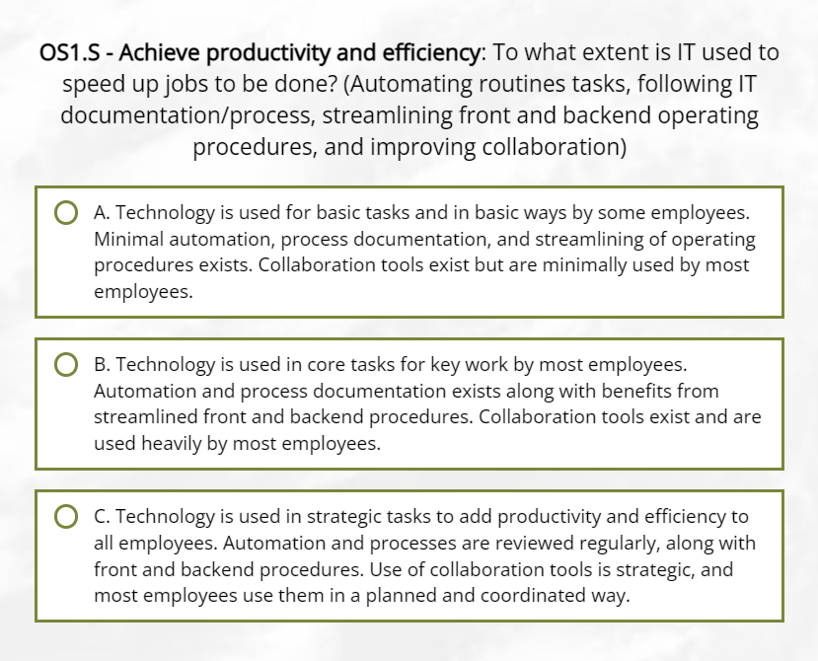
Trait 2: Reduce system costs.
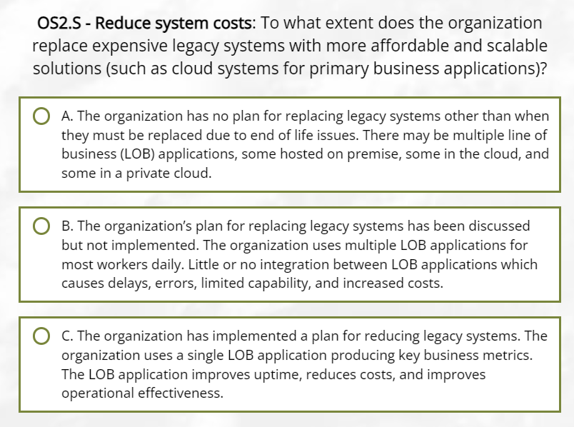
Trait 3: Ensure continuity of work.
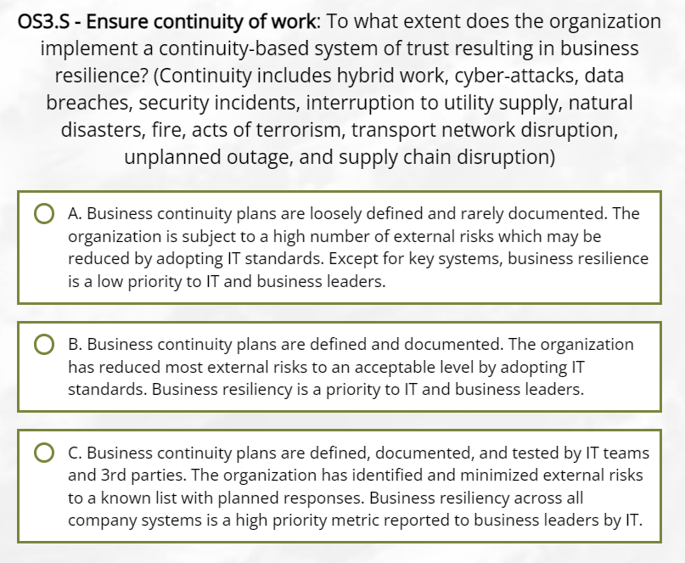
OML Category 2: Governance and Controls
OML Trait 4: Budget for IT expenses
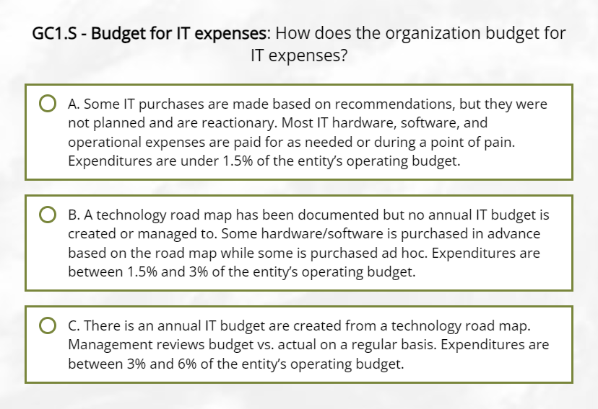
OML Trait 5: Validate overall IT governance, risk, and compliance requirements.
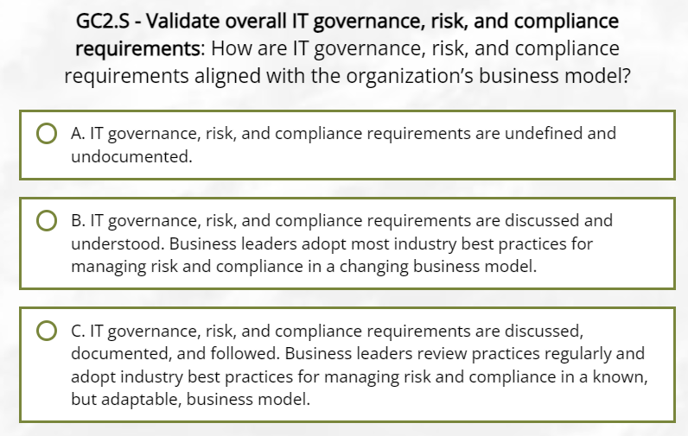
OML Trait 6: Comply with cybersecurity standards and appropriate risk management.
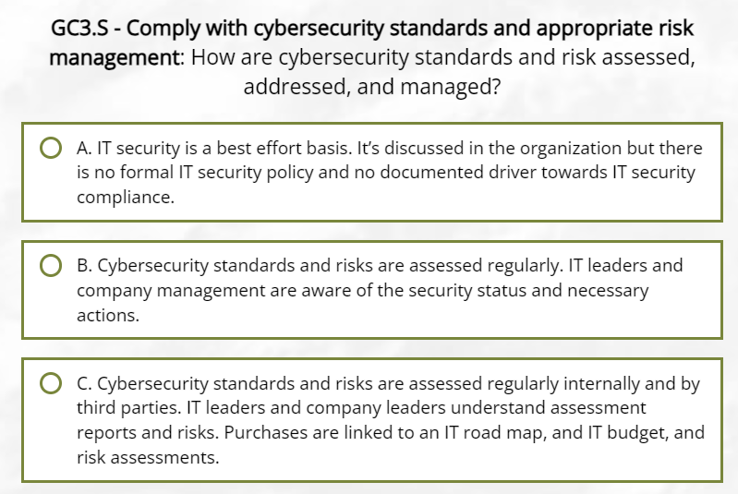
OML Trait 7: Identify focus and contribution from top leaders.
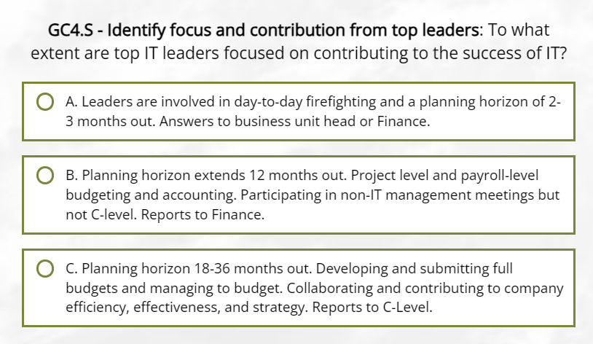
OML Category 3: Strategic Alignment and Business Value
OML Trait 8: Leverage data and analytics.
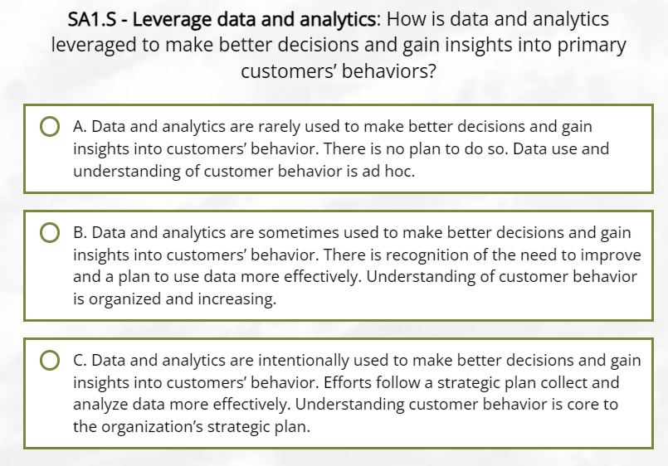
OML Trait 9: Hold business planning meetings to manage IT and vendor relationships.
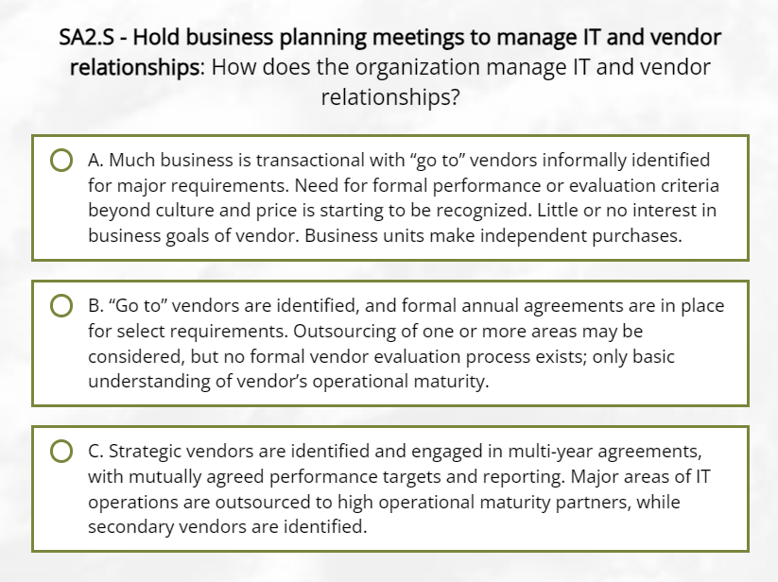

Appendix C: Additional Questions
Client’s alignment with their leadership team.
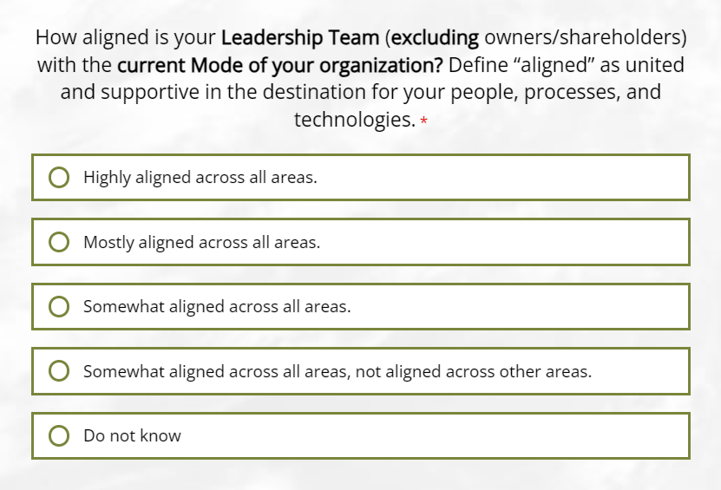
Client’s request to discuss other topics which might impact their business.
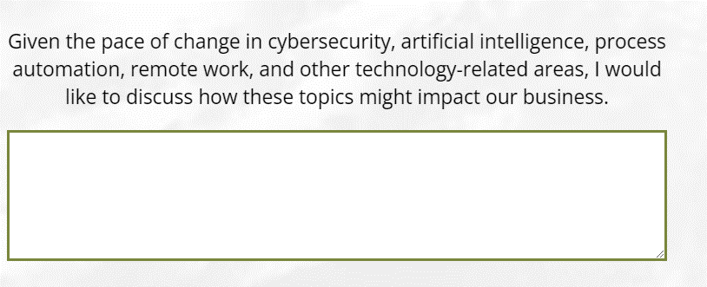

Appendix D: Digital Intelligence & Growth Implementation Plan (Digi-Plan)
A “Digital Intelligence & Growth Implementation Plan" (Digi-Plan) provides a path TSPs may co-create with an SMB business owner to operate successfully in the digital economy. Elements of the plan below – along with what you already know about the client – may align with findings from the Modes Client Assessment in terms of relationship with growth (current or future), OML Traits, and/or technology-related areas which impact the clients’ business.
The outcome of a Digi-Plan review may produce opportunities for 1) transforming the clients’ business in alignment with the TSPs’ offerings, and 2) better aligning both parties with respect to their Modes Mindsets.
- Assess - Evaluate current digital maturity across infrastructure, processes, customer engagement. Identify gaps.
- Envision - Define 3–5-year vision for digital transformation based on customer & industry trends.
- Strategize - Map digital capabilities to business goals, prioritize initiatives with highest ROI.
- Architect - Design seamless workflow between physical and digital operations to create an integrated omnichannel experience.
- Implement - Deploy digital conduits incrementally, focused on quick wins first.
- Integrate - Ensure all digital systems and data connect and share information seamlessly.
- Analyze - Continuously gather digitally connected customer and operational data and optimize based on insights.
- Sustain - Maintain, enhance, and govern digital systems for ongoing efficiency, resilience, and innovation.
- Scale - Expand and upgrade digital conduits to continue elevating capabilities in line with vision.
- Transform - Use the power of digital intelligence to keep evolving the business model and explore new opportunities.

